# MySQL Exam Triple S – SoftUni Stores System

## Because of the fact that the students in the Java Track are the best in SoftUni, with а look into the future, they decided to create databases for all eventually future businesses of the SoftUni. Of course, they have many ideas, but they need to start from somewhere. You have more than year experience, that’s why you were chosen for a senior developer for one of the teams. Your task is to create a store system – SoftUni Stores System. You and the other senior developers create an E/R Diagram, that looks like this. Good Luck.

## Section 0: Database Overview

You have been given an Entity / Relationship Diagram of the SoftUni Stores System:

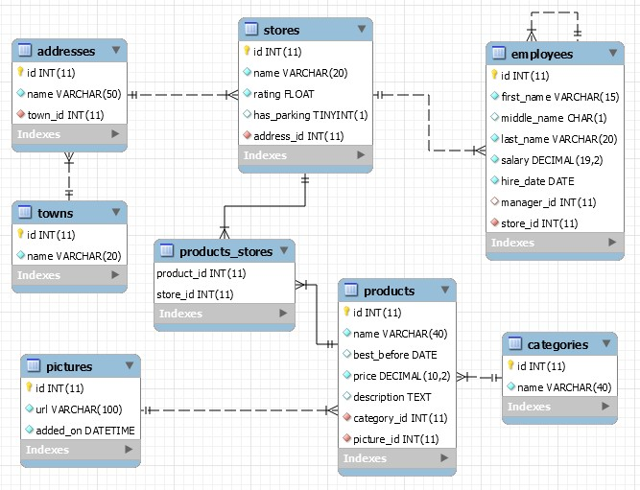

The **SoftUniStoresSystem** needs to hold information about **stores**, **products**, **employees**, **addresses, towns, pictures** and **categories**.

Your task is to create a database called **softuni_stores_system**. Then you will have to create several **tables**.

* stores – contains information about the **stores**.
  + Each store has a name, rating, has parking and relation with addresses.
* products – contains information about the **products**.
  + Each product has a name, best before, price, description and has   
    relations with **categories** and **pictures.**
* products_stores – a **many** to **many** **mapping** table between the **products** and the **stores**.
  + Has a **composite primary key** from product_id and store_id
* employees – contains information about the **employees**.
  + Each employee has first name, middle name, last name, salary and have relations with stores and with self.
* addresses – contains information about the **addresses** of stores.
  + Each address has name and relation with towns.
* towns - contains information about the **towns**.
  + Each town has a name.
* categories – contains information about the categories.
  + Each category has a name.
* pictures – contains information about the pictures.
  + Each picture has a name and date and time when is added on.

## Section 1: Data Definition Language (DDL) – 40 pts

Make sure you implement the whole database correctly on your local machine, so that you could work with it.

The instructions you’ll be given will be the minimal required for you to implement the database.

### Table Design

You have been tasked to create the tables in the database by the following models:

pictures

|  |  |  |
| --- | --- | --- |
| **Column Name** | **Data Type** | **Constraints** |
| id | **Integer,** from **1** to 2,147,483,647. | **Primary Key AUTO_INCREMENT** |
| url | A **string** containing a maximum of **100 characters**. Unicode is **NOT** needed. | **NULL** is **NOT** permitted**.** |
| added_on | A **date** and **time** of adding picture. | **NULL** is **NOT** permitted**.** |

categories

|  |  |  |
| --- | --- | --- |
| **Column Name** | **Data Type** | **Constraints** |
| id | **Integer,** from **1** to 2,147,483,647. | **Primary Key AUTO_INCREMENT** |
| name | A **string** containing a maximum of **40 characters**. Unicode is **NOT** needed. | **NULL** is **NOT** permitted**.**  The name is **unique**. |

products

|  |  |  |
| --- | --- | --- |
| **Column Name** | **Data Type** | **Constraints** |
| id | **Integer,** from **1** to 2,147,483,647. | **Primary Key AUTO_INCREMENT** |
| name | A **string** containing a maximum of **40 characters**. Unicode is **NOT** needed. | **NULL** is **NOT** permitted**.**  The name is **unique**. |
| best_before | A **date** that product is best before |  |
| price | **Decimal number**, up to **10 digits**, **2** of which after the **decimal point**. | **NULL** is **NOT** permitted**.** |
| description | A **very long** String field |  |
| category_id | **Integer**, from **1** to 2,147,483,647. | Relationship with table categories.  **NULL** is **NOT** permitted**.** |
| picture_id | **Integer**, from **1** to 2,147,483,647. | Relationship with table pictures.  **NULL** is **NOT** permitted**.** |

towns

|  |  |  |
| --- | --- | --- |
| **Column Name** | **Data Type** | **Constraints** |
| id | **Integer**, from **1** to 2,147,483,647. | **Primary Key AUTO_INCREMENT** |
| name | A **string** containing a maximum of **20 characters**. Unicode is **NOT** needed. | **NULL** is **NOT** permitted**.**  The name is **unique**. |

addresses

|  |  |  |
| --- | --- | --- |
| **Column Name** | **Data Type** | **Constraints** |
| id | **Integer**, from **1** to 2,147,483,647. | **Primary Key AUTO_INCREMENT** |
| name | A **string** containing a maximum of **50 characters**. Unicode is **NOT** needed. | **NULL** is **NOT** permitted**.**  The name is **unique**. |
| town_id | **Integer**, from **1** to 2,147,483,647. | Relationship with table towns.  **NULL** is **NOT** permitted**.** |

stores

|  |  |  |
| --- | --- | --- |
| **Column Name** | **Data Type** | **Constraints** |
| id | **Integer**, from **1** to 2,147,483,647. | **Primary Key AUTO_INCREMENT** |
| name | A **string** containing a maximum of **20 characters**. Unicode is **NOT** needed. | **NULL** is **NOT** permitted**.**  The name is **unique**. |
| rating | A floating point number | **NULL** is **NOT** permitted. |
| has_parking | Can be true or false | **Default** is **FALSE** |
| address_id | **Integer**, from **1** to 2,147,483,647. | Relationship with table addresses.  **NULL** is **NOT** permitted**.** |

products_stores

|  |  |  |
| --- | --- | --- |
| **Column Name** | **Data Type** | **Constraints** |
| product_id | **Integer**, from **1** to 2,147,483,647. | **NULL** is **NOT** permitted. |
| store_id | **Integer**, from **1** to 2,147,483,647. | **NULL** is **NOT** permitted. |

employees

|  |  |  |
| --- | --- | --- |
| **Column Name** | **Data Type** | **Constraints** |
| id | **Integer**, from **1** to 2,147,483,647. | **Primary Key AUTO_INCREMENT** |
| first_name | A **string** containing a maximum of **15 characters**. Unicode is **NOT** needed. | **NULL** is **NOT** permitted**.** |
| middle_name | A single one character |  |
| last_name | A **string** containing a maximum of **20 characters**. Unicode is **NOT** needed. | **NULL** is **NOT** permitted**.** |
| salary | **Decimal number**, up to **19 digits**, **2** of which after the **decimal point**. | **DEFAULT 0** |
| hire_date | A **date** that employee was **hired** | **NULL** is **NOT** permitted**.** |
| manager_id | **Integer**, from **1** to 2,147,483,647. |  |
| store_id | **Integer**, from **1** to 2,147,483,647. | **NULL** is **NOT** permitted**.** |

Submit your solutions in Judge on the first task. Submit **all** SQL table creation statements.